**Exploratory Data Analysis**

**Project 1**

**Sector performance during and immediately after a recession.**

**By: Ash Tao, Chris Burley,**

**Maica Tran and Sabrina Tsan**

Table of Contents

1. INTRODUCTION 3

Aim 3

2. STEP BY STEP APPROACH 3

Data Fields and Variables – 3

Approach to breakdown the problem 4

**What we already know (Baseline knowledge, research, and studies):** 4

**Cleansing Data** 4

**Analysis** 4

**Time-based analysis** 4

Results - Analysis 5

**1. We can tell some trends from the cause of a recession** 5

**2. Trade volume makes the performance differences:** 6

**3. the previous price can help to make a judgment of buying or selling:** 11

**4. The correlation between sectors become stronger than ever:** 13

**5. Continue holding or buying energy sector doesn't necessarily mean dangerous:** 15

**1 -** **INTRODUCTION**

**Aim:**

The aim of this project is to analyse historical stock market data and attempt to draw insights relating the ways sectors within the S&P500 behave during, and immediately after, a recession. We will try to use those insights to predict future market behaviour. In addition we will seek to determine the factors which impact the length of a sectors recovery, post recession.

**S&P 500:**

The S&P 500 is a group comprising the largest 500 publicly listed companies based on market capitalisation.

The S&P 500 is widely regarded as one of the best indicators of large company performance and of the performance of the stock market more broadly.

**S&P 500: Sectors**

The companies listed on the S&P 500 can be categorised using the following eleven sectors:

|  |  |  |  |
| --- | --- | --- | --- |
| 1. Energy | (2) Material | (3) Industrials | (4) Consumer (Discretionary) |
| (5) Consumer (Staples) | (6) Health Care | (7) Financial | (8) Technology |
| (9) Communications | (10) Utilities | (11) Real Estate |  |

2 - DATA ACQUISITION

Our stock price data and sector performance data was obtained through Yahoo Finance.

## 

**Data Fields and Variables:**

**yfinance**: A python package that downloads market data from the Yahoo! Finance's API.

**yf.download()**: A function which can download the market data based on the selected time period.

With the adjustment of the start and end dates below, we were able to send a request to the Yahoo Finance website and acquire the data we needed for the relevant timeframe.

2 - DATA ACQUISITION (continued)

Once downloaded, the SECTOR data that the yfinance package provides includes:

|  |  |
| --- | --- |
| **Fields** | General field information. |
| **Date** | The date for this record. |
| **Open** | The opening price on that date. |
| **High** | The highest price on that date. |
| **Low** | The lowest price on that data. |
| **Close** | The closing date on that date. |
| **Adj Close** | Amended stock closing price after any corporate actions. |
| **Volume** | Traded volume on that date. |

Once downloaded, the INDIVIDUAL COMPANY data that the yfinance package provides includes:

|  |  |
| --- | --- |
| **Fields** | General field information. |
| **Symbol** | ID for the stock. |
| **Shortname** | Name of the stock. |
| **Longname** | Name of the stock. |
| **Sector** | Sector the stock belongs to. |
| **Industry** | Industry the stock belongs to. |
| **Currentprice** | The latest price of the stock. |
| **Marketcap** | The combined value of all shares for the company. |
| **Ebitda** | Earnings before interest, taxes, depreciation, and amortisation. |
| **Revenuegrowth** | The amount of money the company makes over a pre-determined time period compared to the previous, identical amount of time. |
| **City** | The register city of the stock. |
| **State** | The state of the stock. |
| **Country** | The city of the stock. |
| **Fulltimeemployees** | Number of full-time employees |
| **Longbusinesssummary** | Business summary of the company. |
| **Weight** | The percentage value of each stock in the **portfolio.** |

3 – IMPORTANT DEFINITIONS and BASELINE ASSUMPTIONS

During a recession the total market index will decrease.

History tells us that the market will **ALWAYS** recover from a recession. We know this because it hit a record high in January 2022.

In addition, we know that **ALL** sectors recover from a recession, albeit at different rates. This can be seen in the figure below showing the market ‘bounce-back’ after the most recent recession brought about by COVID 19:

Later in the report, we will feature a deeper dive into the post COVID-19 recession recovery.

3 – DEFINITIONS and ASSUMPTIONS (continued)

For the purposes of this project, please use the following definitions:

|  |  |
| --- | --- |
| **Daily Return:** | A metric for analysing index performance.  It represents the daily change in price as a percentage of the opening price. $$Daily Return=\frac{(Closing Price- Opening Price)}{Opening Price}$$ |
| **Moving Average:** | A [technical analysis](https://www.investopedia.com/terms/t/technicalanalysis.asp) tool that smooths out price data (removing the sudden undulations). It does so by creating a constantly updated [average price](https://www.investopedia.com/terms/a/averageprice.asp).  The average is taken over a pre-defined period, like days, minutes, weeks.  The time period can be updated to suit the needs of the analyst. |
| **Daily Trade Volume:** | The total number of a particular share that are traded on a given day. |
| **Quotient of Recovery (QRec):** | This quotient is a metric which has been designed by the group. It is a measure of how long recovery takes relative to the length of the recession. It allows for the comparison of sector recoveries after recessions of DIFFERENT LENGTHS. |

**Calculating the Quotient of Recovery:**

$$QRec = \frac{Length of Recovery}{Length of Recession}$$

**Using the Quotient of Recovery:**

QRec = 1.5 - Means the recover took 1.5 times longer than the length of the recession.

QRec = 0.75 - Means the recover took 75% of the length of the recession.

**Why use a Quotient of Recovery instead of ‘days’?**

Recovery can indeed be measured in days, and when comparing sector performance after a particular recession it serves us well. The problem we encounter, however, is when we wish to compare sector performances across multiple different recessions. Our group feels that a recovery will likely take longer if the recession, itself, was longer. Thus, having a measure such as QRec, which takes into account the recession length, was seen by the team as beneficial when attempting to compare recovery data for the sectors over time.

3 – DEFINITIONS and ASSUMPTIONS (continued)

**A demonstration of how you might identify the quantities needed to calculate a QRec value.**

|  |  |  |  |
| --- | --- | --- | --- |
| (1) |  | (2) |  |
| (3) |  | (4) |  |
| (5) |  | (6) |  |
| (7) |  | (8) |  |

4 – CLEANING THE DATA

The data retrieved from Yahoo finance does not need to be cleaned. All values of interest are present.

There is no missing data in either the “Sector” or “Marketcap”, CSV files.

5 – RECESSIONS IN FOCUS

Throughout this project the group will perform an exploratory data analysis (EDA) focusing on the first 3 recession periods in the table below.

All 6 recessions in the table will be used in the final section of the project where we seek to find a correlation between the ‘GDP decrease’ observed during a recession and the time since the last recession.

|  |  |  |  |  |  |  |
| --- | --- | --- | --- | --- | --- | --- |
| **Name** | **Start** | **End** | **Duration**  **(Months)** | **Last Recession**  **(Months)** | **Unemployment**  **(Peak)** | **GDP decline**  **(Peak)** |
| **COVID 19** | Feb 2020 | April 2020 | 2 | 128 | 14.7% | −19.2% |
| **Global Financial Crisis** | Dec 2007 | June 2009 | 18 | 73 | 10.0% | −5.1% |
| **Dot Com**  **(9-11 attack)** | Mar 2001 | Nov 2001 | 8 | 120 | 6.3% | −0.3% |
| **Early 1990s** | July 1990 | Mar 1991 | 8 | 92 | 7.8% | −1.4% |
| **Early 1980s**  **(Part 1)** | July 1981 | Nov 1982 | 16 | 12 | 10.8% | −2.7% |
| **Early 1980s**  **(Part 2)** | Jan 1980 | July 1980 | 6 | 58 | 7.8% | −2.2% |

Source: Wikipedia

6 – OUR KEY QUESTIONS

|  |  |
| --- | --- |
|  |  |
| 1 | How long does it take the market and its eleven sectors to recover after a recession? |
| 2 | Do all sectors take the same amount of time to recover after a recession? |
| 3 | Is there a link between the number of days a recession lasts for and the number of days it takes for the market to recover? |
| 4 | Has the market recovered after the Covid 19 recession?  Is the market on a bull or bear trend?  Is it still a good time to invest in the stock market? (Answers are at the end) |
| 6 | Can we use previous recession data to predict how long recovery will take? |
| 7 | Can we identify the cause of a recession? |
| 8 | Are there factors that impact the length and severity of a recession? |
| 9 | What makes one sector perform differently to the others? |
| 10 | Can the previous price help to make a judgment of buying or selling? |
|  | How the GDP during recession?  How stock market reacts during recession?  Is there any correlation between recessions?  Is there any link between GDP and stock market?  Can we tell the trend from the cause of the recession?  What makes one sector perform differently from the others?  Can the previous price help to make a judgment of buying or selling?  Is there a correlation between sectors?  Essentially a bear market is the opposite of a bull market. That means if the market falls by 20% or more from the 52 week high, it has become a bear market. A bear market is generally marked by investor pessimism which can cause prices to continue falling, adding to further negative sentiment. |

**7 – QREC ANALYSIS -** COVID-19 RECESSION

(Feb 2020 – April 2020)

**Data frame showing recovery information for market and sectors:**

**Bar charts showing sector QRecs during COVID 19 Recession:**

|  |  |
| --- | --- |
|  |  |

**7 – QREC ANALYSIS -** COVID-19 RECESSION (continued)

(Feb 2020 – April 2020)

**Insights:**

* All sectors were negatively impacted by the recession, but the severity of that impact varied. This is demonstrated by the fact that:

1. All sectors recorded negative returns.
2. All sectors took at least some time to recover. Consequently, they each have a blue bar on the QRec charts above. The size of each blue bars indicates the duration of the sector’s recovery.

* The market took 1.11 times the length of the recession to recover.
* Real Estate, Utilities, Financial, Industrial, Consumer (Discretionary) and Energy all took considerably longer than the market average to recover.
* Materials, Consumer Discretionary, Health Care, Technology and Communications took considerably less time than the market average to recover despite all taking a hit of some degree.
* The slowest recover was Utilities which took 8.25 times the length of the recession to recover. Energy wasn’t too far behind, taking 6.74 times the length of the recession to recover.
* The fastest sector to recover was Health Care. It only took approximately 26% of the recession duration to recover.

**8 – QREC ANALYSIS -** GFC RECESSION

(Dec 2007 – June 2009)

**Data frame showing recovery information for market and sectors:**

**Bar charts showing sector QRecs during GFC Recession:**

|  |  |
| --- | --- |
|  |  |

**8 – QREC ANALYSIS -** GFC RECESSION (continued)

(Dec 2007 – June 2009)

**Insights:**

* The Financial and Real Estate sectors incurred the biggest percentage losses in value throughout this particular recession. Of the remaining sectors, Consumer (Discretionary) fared best on this metric.
* All sectors were negatively impacted by the recession, but again the severity of that impact varied. As compared to the COVID-19 recession, each sector took a greater amount of time to recover relative to the length of the recession. The fastest sector to recover after this recession was Consumer (Discretionary). It took 58% of the recession length to bound back to pre-recession levels. In the COVID recession the fastest recovery time belonged to the Health Care sector at 26% of *its* recession length. Consumer Staples was the second fastest to recover with a QRec of 1.03.
* The Financial and Real Estate sectors incurred the biggest percentage losses in value throughout this particular recession.
* The market took 2.42 times the length of the recession to recover.
* The variation in recovery times across the sectors is less for the GFC than it was during the COVID-19 recession. The range in QRecs is 4.6 as compared to 8. Sectors had a more similarity negative experience throughout the GFC.
* Except for Consumer (Discretionary), all sectors took longer than the duration of the recession to recover.
* Only Financial and Utilities underperformed by way of recovery as compared to the market average. All others matched or outperformed the market average.

**9 – QREC ANALYSIS –** DOT-COM RECESSION

(March 2001 – November 2001)

**Data frame showing recovery information for market and sectors:**

**Bar charts showing sector QRecs during DOT-COM Recession:**

|  |  |
| --- | --- |
|  |  |

**9 – QREC ANALYSIS –** DOT-COM RECESSION (continued)

(March 2001 – November 2001)

**Insights:**

* All sectors fell in value. The Utilities and Technology sectors fell the most, and the Materials sector the least.
* The Materials sector took only 6 days to recover its losses from this recession. It’s QRec score of 0.02 suggests it recovers in 2% of the time the recession lasted.
* The market took 5.55 times the length of the recession to recover. This Market QRec score is the highest of the 3 recessions analysed, by some distance. (GFC: 2.42 and COVID-19: 1.11)
* 5 of the 10 sectors were nearly unaffected by this recession, with Communications, Technology Utilities, Health Care and Industrials taking the brunt of the downturn.
* The Communications sector recorded a QRec score of 27.93, meaning that it took 6872 days to recover. Relative to other sectors in the same recession, no sector has taken a bigger hit. The second highest QRec score for the Dot-Com recession belonged to Technology at 8.45. This score represents only 30% of the Communications QRec score.

In the GFC the second highest QRec score was 63% of the highest.

In the COVID 19 recession the second highest QRec score was 82% of the highest.

*Please note that the Real Estate sector data is not available for the Dot-Com recession or any other recession prior.*

**10 - ANALYSIS –** ALL 3 Recessions (continued)

**QRec scores for each sector in all three recessions:**

**Average QRec scores for each sector across all three recessions:**

**Insights:**

* As we can throughout the past three recessions, Consumer related sectors recovered at the fastest rate, followed by the Materials sector. That means a recession has the capacity to bolster the strength of these two sectors relative to the other nine.
* The Communications sector has been the slowest to recover in the past three recessions, primarily due to being hit so hard, relative to the rest of the market, throughout the Dot-Com recession. It might also be explained by the fact that consumers prioritise the purchase of food and essential services during recessions and spend less of their income on products and services supplied by other sectors.

**11 – Post COVID-19 Recession (A deep dive)**

As discussed in section 3 of this report, the market and all eleven of its sectors have recovered from the COVID-19 recession. Each has hit record heights in terms of price in recent months.

We will now investigate this ‘bounce-back’ in greater detail. The following charts are based on stock market data from the end of the recession until 27/3/2022.

|  |  |
| --- | --- |
| **Adjusted S&P500 Close Price since the end of the COVID-19 recession:**   | **Revenue Growth by Sector since the end of the COVID-19 recession:**   |
| **Weight by Sector since the end of the COVID-19 recession: Date (27/3/2022)**   | **Weight by State since the end of the COVID-19 recession: Date (27/3/2022)**   |

**11 – Post COVID-19 Recession (A deep dive) (continued)**

**Insights:**

* We can see from the Adjusted S&P500 Close Pricechart above that the S&P 500 market has increased in overall value by more than 90%.
* All sectors have experienced positive growth, led by Consumer (discretionary) with 34.28% growth since the end of the recession. It is likely that Tesla has contributed significantly to that result, growing a whopping 12% in the 9 days leading up to the 27th of March, 2022.
* Consumer (discretionary) is a sector classified as providing non-essential goods and services. Consumers tend to spend more on Consumer (discretionary) products in economic growth phases, when individuals have more disposable income.
* The Technology sector makes up almost a quarter (23.68%) of the S&P 500 total weighting.
* The largest U.S. companies, based on Market Capital, are Apple, Microsoft, Alphabet, Amazon and Facebook. They currently account for 17.5% of the S&P 500. That means that anyone who invests in the SPDR S&P 500 ETF is simultaneously investing heavily, and perhaps unknowingly, in these companies too.

**12 – GDP/Economy Vs Stock Market during recessions.**

1. Recession period comparison



The 1990s were the longest period of economic growth in American history up to that point. The collapse of the speculative dot-com bubble, a fall in business outlays and investments, and the September 11th attacks, brought the decade of growth to an end.

**12 – GDP/Economy Vs Stock Market during recessions.**

1. How the economy reacted to the recession from 1980 to 2020

GDP and unemployment declined. Covid 19 lasted only two months, but it hit the worst.

The rates of GDP and unemployment were the highest

**12 – GDP/Economy Vs Stock Market during recessions.**

1. The relationship between the economy and share market

The graph below shows it is a negative relationship between GDP declined and Time since last recession

Several studies (Dimson et al. [2002], Ritter [2005]) found that the correlation between stock returns and GDP can be negative

The graph “ GDP Growth and S&P 500 Returns 1980 – 2000, GDP was quite stable. In comparison, we can see S&P_500 had dramatic fluctuations. The highest point and lowest point were 29.30 and -39.20%

**12 – GDP/Economy Vs Stock Market during recessions.**

The graph above showed that there was no correlation between GDP and S&P 500 companies

Conclusion: it is concluded that GDP usually has a negative trend whenever there is an economy recession: high unemployment rate. In contrast, share return still performs well although it has fluctuations.

Limitation:

It cannot predict the future share price because of the world volatility and ongoing Ukraine war.

1. Recession period comparison

**13 – Closing Price Vs Cause**

**13.1 The performance of each sector varies, some sectors gain, and some lose.**

International events can lead to market recessions. Because of the different nature of events, the market will behave differently during a recession.

Some sectors related to the causes of the recession may have the biggest losses and become disaster areas. (e.g., the financial sector experienced the largest losses in 2008 GFC).

And some may be affected less during the recession. (e.g., the health sector in covid, has the least loss).

Furthermore, people's predictions about the future will also affect the current market.

* **COVID-19 – Feb 20 to Apr 20**

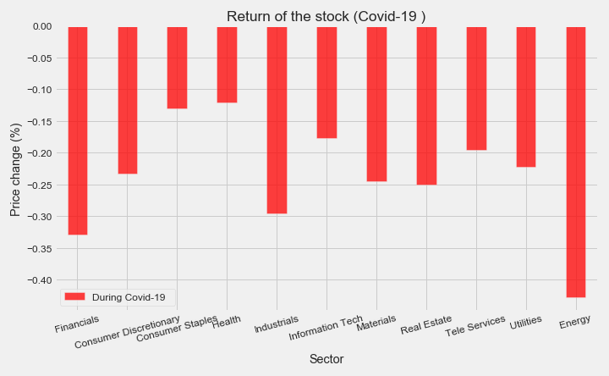

All sectors fell, the energy sector fell the most, and the health sector fell the least.

The recession is caused by a global pandemic.

* **The financial crisis (GFC) – Dec 07 to Jun 09**

All sectors fell, the financial sector fell the most, and the health fell the least.

The financial crisis was primarily caused by deregulation in the financial industry.

* **Dot-Com bubble – Mar 01 to Nov 01**

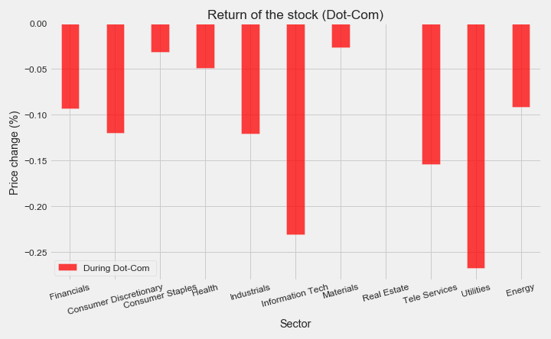

All sectors fell, Utilities fell the most, and Materials fell the least. No information on Real Estate backs that time.

**14 – Closing Price Vs Volume**

**13.2 The causes of a recession can help predict the trend of the market.**

Based on the causes of the recession, people can predict a little bit sector’s performance regarding the cause of the recession.

**13.3 Limitation**

However, the cause is often discovered after the market has crashed due to the long tail effect of the market. Therefore, the judgment only based on the cause will not make a big difference.

### **2. Trade volume makes the differences on sector performance:**

**2.1 Trade volume reflects market confidence and will affect the price.**

Volume measures the number of shares traded in a sector. Volume can indicate market strength. From the plot we generated, we found that “Daily Trade Volume" and "Daily Retune" seem to have similar patterns through observation.

* **COVID-19 – Feb 20 to Apr 20**

* **The financial crisis (GFC) – Dec 07 to Jun 09**

* **Dot-Com bubble – Mar 01 to Nov 01**

There is no daily trade volume data during the Dot-Com bubble.

**15 – Daily Return Vs Daily Volume**

**2.2 There is a pattern between Daily Return and Daily Volume**

The peaks and deeps on Return & Volume always seem to appear in pairs.

The turning point of volume (the direction change of acceleration) often indicates the turning point of return.

* **COVID-19 – Feb 20 to Apr 20**

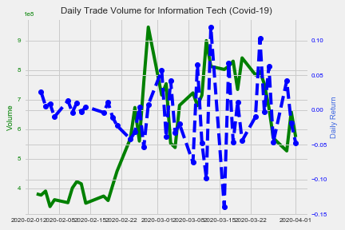**

* **The financial crisis (GFC) – Dec 07 to Jun 09**

**16 – Daily Return Vs Daily Volume (continued)**

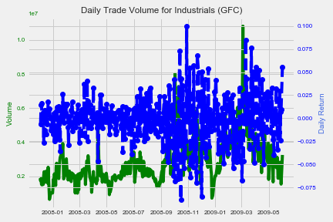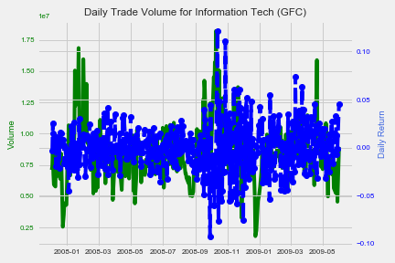

* **Dot-Com bubble – Mar 01 to Nov 01**

There is no daily trade volume data during the Dot-Com bubble.

**2.3 Daily Return and Daily Volume can help predict the trend of the market.**

Daily Return and Daily Volume are closely related due to their definitions. The daily trading volume affects the price, and the daily return is obtained by the price. Mathematically speaking, there is a correlation between these two.

From a market perspective, trading volume can help investors identify market trends.

If the volume keeps moving on one way, the price usually does not change its direction. In other words, if the volume trend remains unchanged (continuously increasing or decreasing), the price trend does not change. At this point, it is safe to keep the strategy you have.

If the volume trend changes, from increasing to decreasing (or a decrease becomes an increase), which means that the price is facing a reversal point. At this point, you may need to consider changing your strategy.

**2.4 Limitation**

However, in theory, the above statement is correct. But in the real world, this theory might not work due to various reasons. For example, volume changes every second, and we can only know the change of trend after it crosses the extreme value. Therefore, the relationship between Volume and Return is not enough to help investors make a clear judgment. But there is indeed a close correlation between them, and volume can reflect investors' confidence and interest in the market.

### **3. the previous price can help to make a judgment of buying or selling:**

**3.1 The moving average (MA) can help smooths out price data and help the judgment.**

As can be seen from the plot below, the daily closing price moves up and down around the average line and make crossovers. The different average lines also crossed.

**17 – Moving Average**

The moving averages can help to identify trend direction and to determine support and resistance levels.

The short-term average is trending closer to price.

* **COVID-19 – Feb 20 to Apr 20**

* **The financial crisis (GFC) – Dec 07 to Jun 09**

* **Dot-Com bubble – Mar 01 to Nov 01**

*No real estate price data during the Dot-Com period. The plot of this sector is blank*

**18 – Moving Average (continued)**

**3.2 The moving average (MA) can help predict the trend**

Crossovers are one of the main moving average strategies.

First, we can judge by the crossover on the closing price and the moving average line. When the price crosses above or below a moving average, there will be a signal for change in trend.

Second, we can judge by the crossover on the short-term and long-term moving average lines. When the shorter-term MA crosses above the longer-term MA, it's a buy signal, as it indicates that the trend is shifting up. This is known as a golden cross. Meanwhile, when the shorter-term MA crosses below the longer-term MA, it's a sell signal, as it indicates that the trend is shifting down.

**3.3 Limitation**

Moving averages are calculated based on historical data and nothing about the calculation is predictive in the real world. if the price becomes choppy, the price may swing back and forth, generating multiple trend reversals or trade signals. When this occurs, we need another indicator to help clarify the trend.

If prices start fluctuating, sometimes the market won't respect MA support/resistance trade signals. Moving averages work well in strong trending conditions but poorly in ranging conditions.

**19 – Daily Return Heatmap**

### **4. The correlation between sectors become stronger than ever:**

The correlations between the various industries are getting tighter over time. The colour of the plot is getting warmer.

The colour of the heat map is getting warmer means that all industries are getting closer than ever due to the Cross-Industry. Thus, during the recession, no matter which sector you invest in, it will be affected strongly by others.

* **COVID-19 – Feb 20 to Apr 20**

* **The financial crisis (GFC) – Dec 07 to Jun 09**

* **Dot-Com bubble – Mar 01 to Nov 01**

To understand it, let's use Apple as an example. If Apple sells strongly on its newly released products (iPhone, Mac Book, etc.), then all companies in its supply chain, such as mobile phone accessories manufacturers or retailers, will have a good business performance as well. Their stock price will go up, and their sector is different from Apple.

**19 – Daily Return Heatmap (continued)**

Therefore, when making investment decisions, the correlation between sectors should be a very important consideration. Regarding this topic, other data need to be introduced from different perspectives. We won’t be able to discuss it more deeply here.

**\* – CHRIS’S SETTING OUT OF MAICA’S SECTION (DELETE)**

**Potential Correlation 1:**

Are recessions becoming progressively shorter in duration?

To investigate this potential correlation, we constructed a bar chat showing the duration of each recession since the beginning of the 1980s. The x-axis has been ordered in such a way that the recessions appear in chronological order.

**Insights:**

* There is no apparent trend in this data. It is unlikely that a correlation exists between the recency of a recession and its length.

**Potential Correlation 2:**

Is there a correlation between GDP decline and Unemployment?

Could we possibly reverse the order of the x axis values?

Could we possibly order the blue lines in ascending height order?

This will better show the decline in orange lines.

**Insights:**

* Based on the data associated with the past 6 recessions, there appears to be a correlation between GDP declines and unemployment. As GDP plumets, unemployment rates rise.

**\* – CHRIS’S SETTING OUT OF MAICA’S SECTION (DELETE)**

**Potential Correlation 3:**

Is there a correlation between GDP decline in a recession and the time since the last recession?

**Insights:**

* No correlation.
* $r-squared=$ 0.1937

**Potential Correlation 4:**

Is there a correlation between GDP growth in a calendar year and S&P500 returns?

**Insights:**

* No correlation.
* $r-squared=$ 0.0011